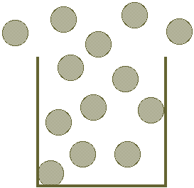
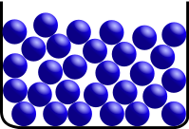
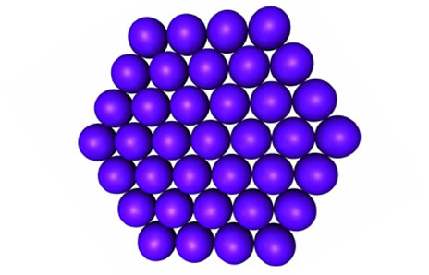
Energy__________________________
Energy__________________________

Energy__________________________
Energy__________________________

SUBLIMATION – direct change to gas – no liquid phase

MELTING EVAPORATION

(vaporisation)

SOLID LIQUID GAS
FREEZING CONDENSATION

(solidification)
DEPOSITION – changing directly to solid – no liquid phase

